Appendix A – PDI as a Data Source

PDI Report Generation

A common PDI deployment use both a File and Pentaho repository. Running a simple transformation a few times to generate the reports may be acceptable. However, when the workflow is scaled to include many reports, the challenge is to then automate the ETL process.

1. Open the Job: kjb_download_report.kjb

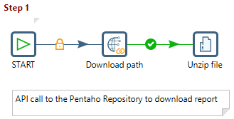

The download workflow needs to be looped to retrieve all the reports.

1. Open the Transformation: ktr_loop_download_report_main.ktr

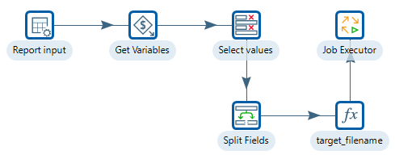

1. Open the folder: C:\PDI Report Generation\to_process

In this workflow, just the Invoice report has been downloaded and unzipped. The next step is to loop through the reports, generating the output pdfs.

1. Open the Transformation: ktr_generate_report.ktr

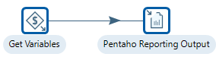

1. Open the Transformation: ktr_loop_generate_report.ktr

